**West Coast Collaborative**

**Test 1 2016**

**Calculator Free Section**

**Name: _______________________ Score: _____ / 31**

**Section 1 is worth 50% of your final test mark.**

**No calculators or notes are to be used.**

**Access to approved Sample Mathematics Specialist formulae sheet is permitted. Time limit = 30 minutes.**

**1. (4 marks)**

Given that *z* is a complex number solve  , giving the solution(s) exactly in the form *a* + *bi*.

**2. [3 marks]**

Rewrite as a Cartesian equation.

**3. [ 2,4,2 marks ]**

The polynomials p(x) and Q(x) are defined as follows:

P(x) = , Q(x)= 

**a)** Show that x-1 and x+1 are factors of P(x)

**b)** Determine a and b if Q(x) leaves a remainder of 37 when it is divided by , and a remainder of -19 when divided by 

**c)** With these values a and b, determine the remainder when the polynomial 4P(x) + 5Q(x) is divided by 

4. [ 3,3 marks]

**a)** Given $z=a-3i$ and $z+c\overline{z}=12+6i$, determine $a$ and $c$.

**b)** Given $w=bcis\frac{5π}{6}$ and $\left|{\left(\overline{w}\right)}^{3}\right|=0.001$, determine $b$

and give the principal argument of $w^{3}$.

**5. [5 marks]**

Use De Moivre's Theorem to find all the roots of z4 = -8 + 8√3i. Give your answers exactly in polar form, with r >0 and .

**6. [ 5 marks ]**

Find all the values, real and complex, of x for which G(x) = 0,

If G(x) = 5x3-15x2+5x-15

**END OF SECTION 1**

**West Coast Collaborative**

**Test 1 2016**

**Calculator Section**

**Name: _______________________ Score: _____ / 29**

**Section 1 is worth 50% of your final test mark.**

**Calculators allowed and 1 page of A4 notes, writing on both sides.**

**Access to approved Sample Mathematics Specialist formulae sheet is permitted. Time limit = 30 minutes.**

**7. [2, 2, 2, 2 marks]**

Suppose that z is a complex number with modulus r and argument θ.

Express in terms of r and θ the modulus and argument of each of the

four complex numbers z1, z2, z3, and z4 where

( i ) z1 = z2

( ii ) z2 = 2z

( iii ) z3 = z-1

( iv ) z4 = -iz

**8. [ 2,2,2 marks]**

The complex numbers of *z* and *w* are such that:

*z* = 3cis(  ) and *w* = cis(  )

Determine the following.

**a)** *z* + *w* (in a + b***i*** form) **b)** *w z* (in cis form)

**c) $\frac{1}{\overline{z}}$** (in cis form and a + b**i** form)

**9. [** **5,5 marks** **]**

**a)** On the Argand Diagram below, sketch and label both of the sets of points specified:

**i)**  **ii)** 

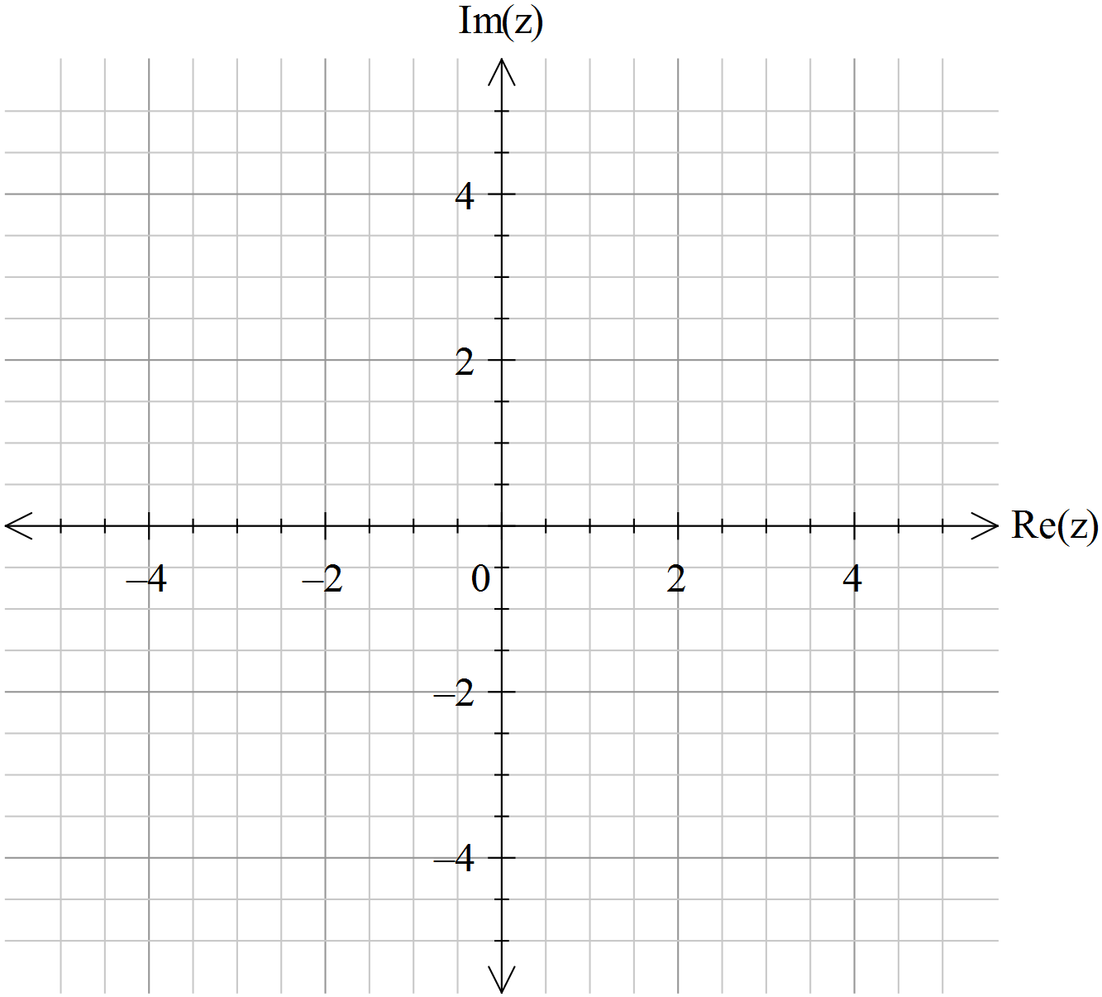

**b)** Determine to four decimal places the largest possible argument, , of the complex number that satisfies 

**10. [ 4, 1 marks]**

**a)** Use de Moivre’s theorem to show that $\cos{4x}=\cos^{4}{x}+\sin^{4}{x}-6\cos^{2}{x}\sin^{2}{x}$

**b)** Use this result to show that $\cos{4x}=1-8\cos^{2}{x}\sin^{2}{x}$

**END OF SECTION 2**